ClientLine Enrollment https://www.myclientline.net/welcome.html

Please call the ClientLine Help Desk number @ 800.285.3978 (option 2 / option 1) if you need assistance with enrollment.

- Click Enroll on the Create an Account tab

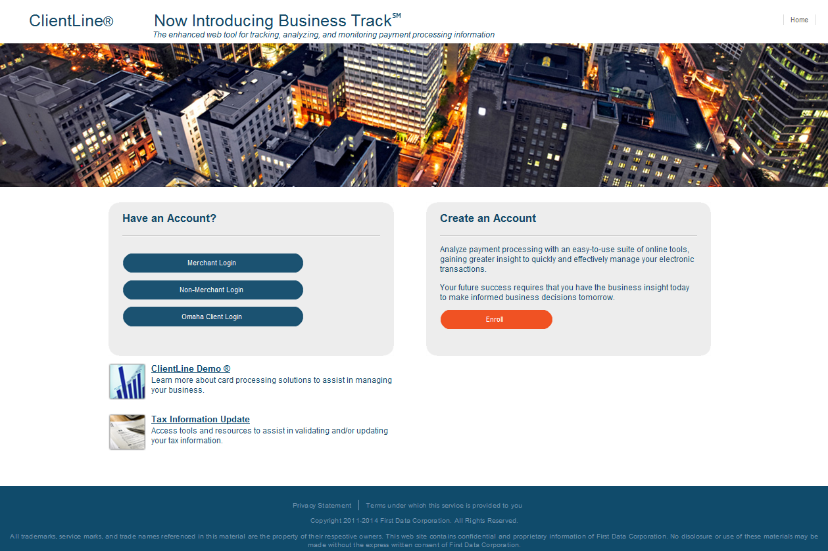

- Click Begin Enrollment

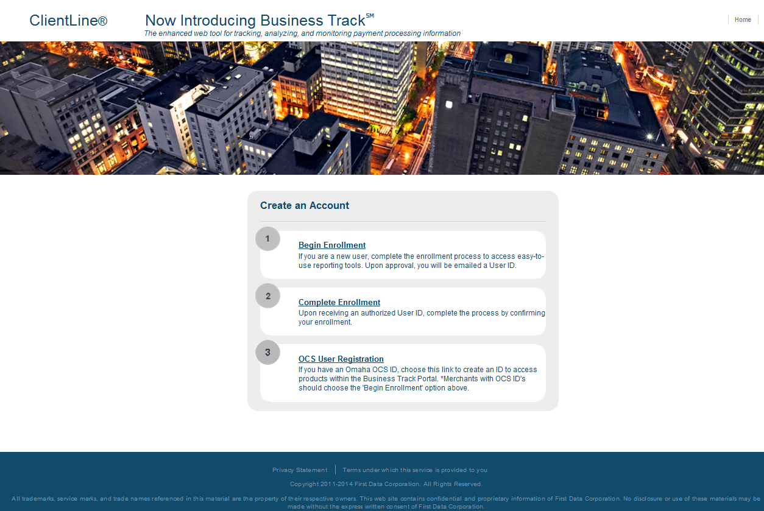

- Input the following:
  - Merchant # (xxxxxxxxxxxx)
  - Business Checking Account #
  - Tax ID
  - Bank Sort Code/Transit # (leave blank)
  - First Name
  - Last Name
  - Zip / Postal Code
  - Phone Number
  - Email
  - Select Language
  - Select Security Question
  - Security Question Answer
  - Image Validation
Click Next
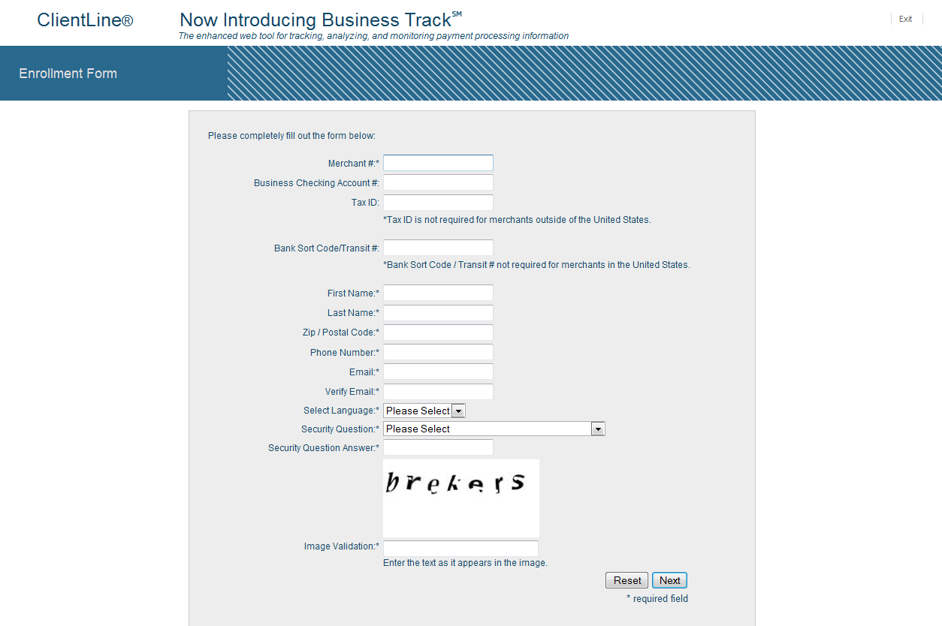

- Upon receiving an authorized User ID, confirm your enrollment.
  - Click Confirm Enrollment

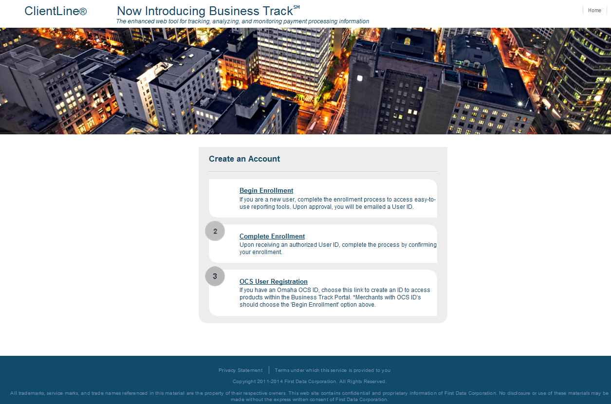
- Input the following:
  - User ID
  - Image validation
Click Next

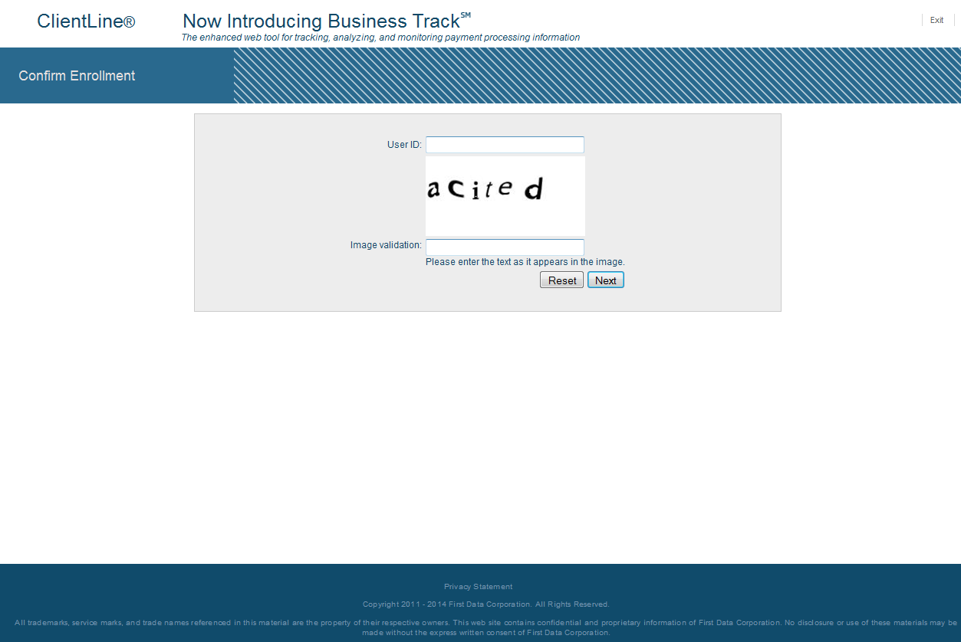

- Please answer your secret question
Click Next

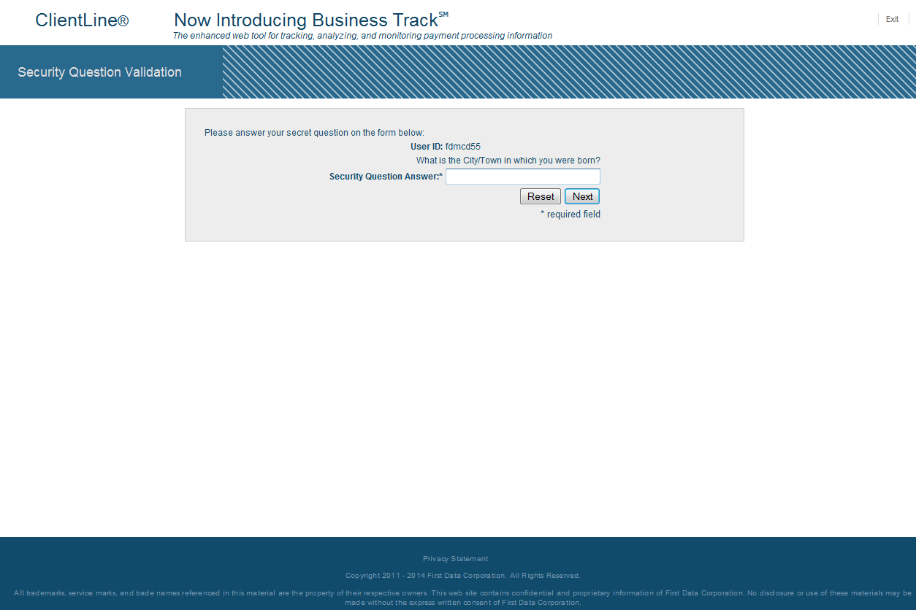
- Temporary password will be provided
- Login https://www.myclientline.net/welcome.html
- Update password

