PART 1 – Create a CAP account (only needs to be performed once)

- Navigate to https://pnp.valididcloud.com/

- Click “Access”.
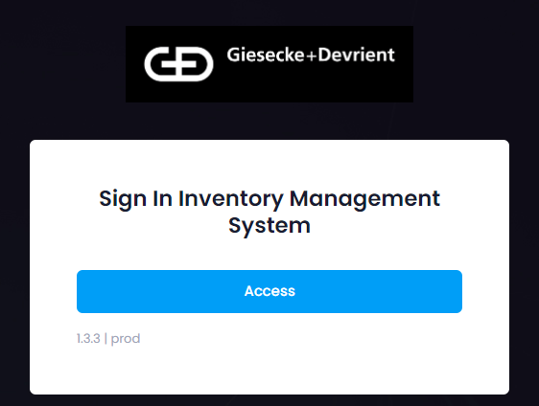

- Click “Create an Account”.
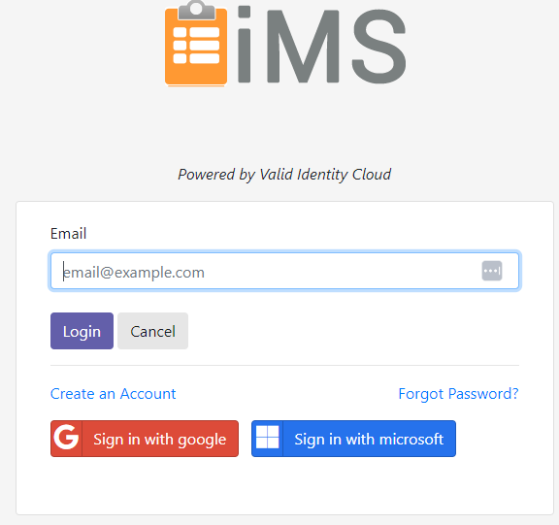

- Fill out these fields: “Email Address”, “First Name”, “Last Name”, “Password”, “Confirm Password”
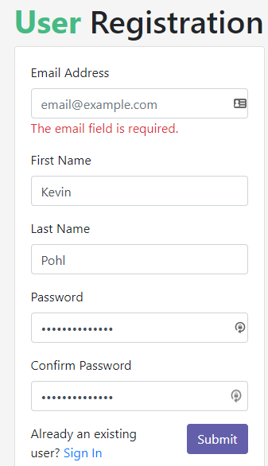
Go to the next page.

- Click “Submit”, then you’ll see a message that says “Confirm Email Sent”.
- Click Return to “Sign In”.
- Check your inbox for an email with the subject “Valid Id Cloud new user confirmation”.
- In the body of the email, click “here”.
- Your browser will open. On the “Email Confirmation” page, click Return to “Sign In”.
- On the “Welcome to Valid Identity Cloud” page, click “Sign In”.
- Enter your email and click “Login”.
- Enter your password and click “Continue”.
- Click “Continue” again.
- Click “Continue” again.

After a CAP user has been created, please email mark.johnson1@Fiserv.com and an invite email will be sent.

15. After receiving the invite, click to accept the invitation. The iMS team will then add you to the system. This can take a few hours. (If you are unable to find the invite email, please make sure to check junk or spam folders.)
16. Once your user has been added to the system, proceed to Part 2 of the instructions – Log into iMS

Go to the next page.
PART 2 – LOG IN TO iMS

- Navigate to this URL in your browser:
https://pnp.valididcloud.com/

- Click “Access” on this page:

- Enter your email address and click “Login”:
Note: Email needs to be the same email address used when creating your CAP user
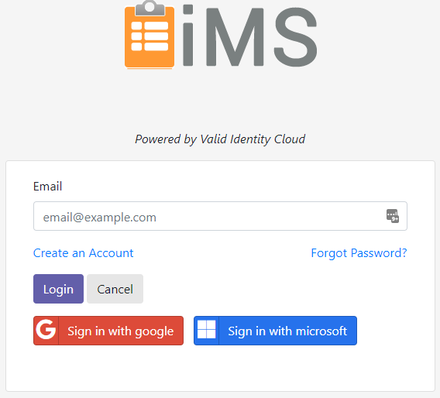

Go to the next page.

- Enter your password and click “Continue”:
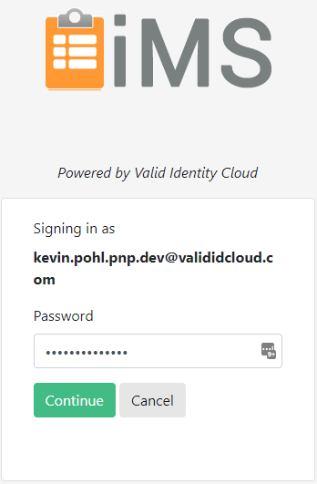

- Click “Continue” on this screen:
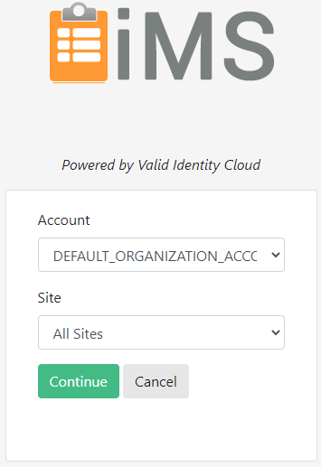

Go to the next page.

- You should now be at the home page of the iMS site
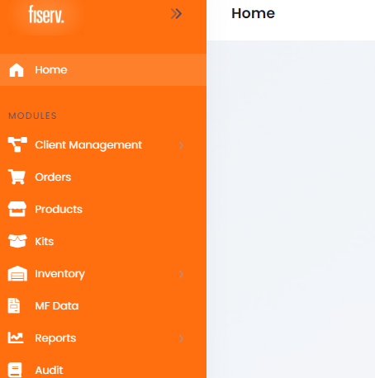

Done.

